**Money Buys Happiness? Not After You Hit Six Figures**

by [**Richard Carrier**](https://www.richardcarrier.info/archives/author/rcarrierinfidels-org) on [**April 7, 2018**](https://www.richardcarrier.info/archives/13954)[**30 Comments**](https://www.richardcarrier.info/archives/13954#comments)

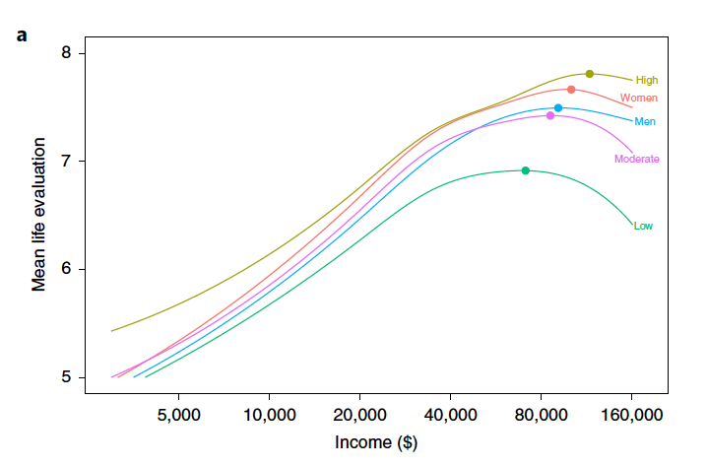

Five years ago I took Michael Shermer to task for pushing pseudoscience in his bungled attempt to argue (in agreement with Sam Harris and myself) that moral philosophy could and should be retooled into a proper empirical science, [**the same way**](https://www.richardcarrier.info/philosophy.html) every other philosophical subject has before (from cosmology and philosophy of mind, to actual biology and physics), in [**Shermer vs. Pigliucci on Moral Science**](https://www.richardcarrier.info/archives/3245). There I pointed out how Shermer violated basic tenets of skepticism and tried selling some snake oil wigwash as established science. I made some points about the (non-peer-reviewed) study he mis-used and showed that it supported just as easily conclusions quite the contrary of his own. And that this is therefore not what Sam Harris and I mean by turning morality into a science. We mean an *actual* science. With standards.

Well, just this year a new, large, and fully peer reviewed study was published that confirmed nearly every point I made. Here I’ll summarize the findings of that study, and their significance for moral and political philosophy, written by Andrew Jebb, Louis Tay, Ed Diener, and Shigehiro Oishi, “[**Happiness, Income Satiation and Turning Points around the World**](https://www.nature.com/articles/s41562-017-0277-0),” *Nature: Human Behaviour* 2.1 (January 2018): pp. 33-38.

***Approach and Basic Findings***

The official abstract reads:

Income is known to be associated with happiness, but debates persist about the exact nature of this relationship. Does happiness rise indefinitely with income, or is there a point at which higher incomes no longer lead to greater well-being? We examine this question using data from the Gallup World Poll, a representative sample of over 1.7 million individuals worldwide. Controlling for demographic factors, we use spline regression models to statistically identify points of “income satiation.” Globally, we find that satiation occurs at $95,000 for life evaluation and $60,000 to $75,000 for emotional well-being. However, there is substantial variation across world regions, with satiation occurring later in wealthier regions. We also find that in certain parts of the world, incomes beyond satiation are associated with lower life evaluations. These findings on income and happiness have practical and theoretical significance at the individual, institutional and national levels. They point to a degree of happiness adaptation and that money influences happiness through the fulfilment of both needs and increasing material desires.

The actual study is an even more interesting read. With a sample size of nearly two million people, its results command attention. It worked like this: They studied three measures of correlation between “happiness” and “annual income” (as adjusted U.S. dollars, to allow cross-region comparison): degree of “life evaluation,” frequency of positive emotions, and frequency of negative emotions.

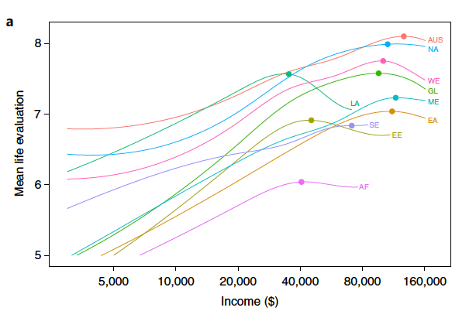No one was ever asked if they were happy or how happy they are. But instead were asked questions, in the first place, about their overall feeling about their lives in a generic way, and in the second place, about the kind of emotions they had predominately experienced the previous day. The former measure is effective because it avoids disparities in how people classify or define the word “happiness” or “happy.” And the latter measure is effective because random factors (like, say, having just lost a loved one the week before) get randomized in such large samples, to produce a measure of how frequently people at various income levels experience certain emotions (like, say, how often people at a certain income have to deal with grief over a lost loved one; and every other possible thing that impacts emotional state).

**Life evaluation:** participants were asked “to imagine a ladder with steps labelled 0 [to] 10, where 0 represents the ‘worst possible life’ and 10 is the ‘best possible life’ [and to] indicate at which step of the latter they personally stand at the present time.” Note that’s an 11 point scale (because of the inclusion of a possible 0).

**Affective well-being:** subjects were asked “whether they had experienced an emotional state for much of the day yesterday.” For the positive affect measure (positive emotions), “the emotional states [measured] were happiness, enjoyment and smiling/laughter.” For the negative affect measure (negative emotions), “the emotional states [measured] were stress, worry and sadness.”

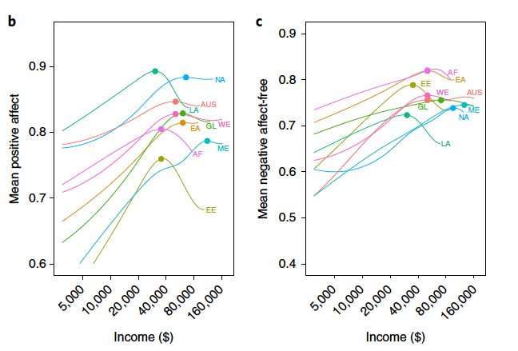With this approach, they found what all previous studies found (including the one Shermer falsely claimed had disconfirmed it): that once annual income hits a certain point, there are no significant gains in happiness after that. In other words, more money, is no use to us. Not as far as living a life worth living. In fact, this study found that sometimes, more money after that point actually *decreases* life satisfaction! Called “satiation,” the income level where this occurs did vary by country and region (and a little bit by education and gender: e.g., see the graph at the top of this article), but it actually remains fairly close to a universal standard, when controlling for achievability (i.e. when comparing regions where the same level of life satisfaction is reached on average *at* satiation; vs. regions where it can’t be, maybe owing to the region sucking too much to make such levels of happiness possible).

In general, averaged globally, “the satiation point for life evaluation occurred at approximately $95,000, at roughly 7.58” and “for positive emotions, satiation occurred at a lower level of income ($60,000), as did [the reduction in] negative emotions ($75,000).” Peak “positive emotion” days averaged at above 80% and “negative emotion free days” at around 75% (vs. a bottoming-out in poverty of around 60% and 65%, respectively). And “for all three measures…there were no appreciable increases in [subjective well-being] after these incomes.” In fact, “after satiation had been reached” for the life-satisfaction measure, “further increases in income were associated with slight decrements” to subjective well-being (which they called ‘turning points’, where increases started to reduce life satisfaction). This was even observed for the emotion measures, although not significantly (except for certain regions or conditions, e.g. incomes above satiation led to worse average emotional states in Latin America and Eastern Europe, and globally for people who had not attained the equivalent of a high school graduation).

**Update:** Note that all the numbers I supply in this article are for single individuals. For families, “households with more people,” the study found you have to “multiply the satiation estimate by the square root of the household size,” so “a household with four members would have a satiation point two times higher than the estimates reported here.” And for a couple with no children, that multiplier is roughly 1.41. So joint income for a couple will hit satiation at $141,000 when individuals hit it at $100,000; and a family of four in that same circumstance, hits it at $200,000. So generally still always low six figures.

***Variations Were Relatively Minor***

Even when we look at the variations, they don’t significantly change that general picture.

Higher satiation points on life-evaluation spanned $100,000 (Western Europe & Scandinavia) to $125,000 (Australia & New Zealand), and no higher, for example. This condition existed basically in wealthy nations (e.g. in North America, it was $105,000), where getting by—indeed, getting a lot of things—is more expensive. But a range of $95,000 to $125,000 worldwide is not that substantive a difference. Pretty much everywhere, you max out your life satisfaction as soon as you hit a six figure income. After that, you gain nothing. There was a different cluster of regions where the satiation point for life-evaluation was a lot lower, ranging from $35,000 (Latin America & the Caribbean) to $70,000 (Southeast Asia), with regions in that cluster including Eastern Europe and Africa. However, these regions also experience a lower maximum life satisfaction. In other words, they can’t even achieve the levels of happiness people in other regions can (and more people fail to achieve even the maximum that’s locally available); consequently, those who can get there at all, max out on what they can achieve, earlier. Those regions also tend to have lower costs of living, which may also be a factor.

For example, “Latin America/the Caribbean satiated at one of the lowest points” in their sample (satiation at $35,000, with an average life evaluation score of 7.57); likewise Southeast Asia ($70,000, at 6.84). Whereas “Northern America ($105,000) and Western Europe/Scandinavia ($100,000) satiated at much higher incomes, but also with significantly higher levels of evaluation (7.98 and 7.75, respectively).” Still, these differences might not seem that great in some cases. Even accounting for these differences, Latin America and the Caribbean seem to be much happier places in general, *for those who can obtain the optimal income level* (which does not mean the majority of the people there do). There may be cultural or environmental factors worth studying there.

Indeed, you should familiarize yourself with the summary report of Esteban Ortiz-Ospina and Max Roser, “Happiness and Life Satisfaction” (2017 ed.) at [***OurWorldInData.org***](https://ourworldindata.org/happiness-and-life-satisfaction). As one of their referenced [**reports**](https://s3.amazonaws.com/happiness-report/2018/WHR_web.pdf) notes:

Latin Americans report high happiness levels. Positive-affect scores are substantially high both in comparison to other countries in the world and to what income levels in the region would predict. Latin Americans’ evaluation of life is also above what income levels would predict. It is clear that there is more to life than income and that there is something to learn from the Latin American case about the drivers of happiness.

The average life evaluation score across that region is around 6 (vs. a little above 7 in the U.S.), though it is of course higher in some countries and lower in others (the highest: 7.14 in Costa Rica; the lowest: 4.93 in the Dominican Republic). This despite much lower incomes and other troubles in those regions. The disparity researchers credit to “the abundance of family warmth and other supportive social relationships frequently sidelined in favor of an emphasis on income.” In other words, “happiness in Latin America has social foundations.” Which is worth studying. That needn’t mean *traditional* family networks, however; created families, of built friendship networks, do the same thing, as do other forms of social community involvement, as I’ve noted before in addressing attempts to claim religion makes people happy, when in fact it’s just social networks that do (see [**Atheism Doesn’t Suck**](https://www.richardcarrier.info/archives/4291); also relevant are my observations in [**Poly Family, Poly World**](https://www.richardcarrier.info/archives/9835)).

Similarly, variations by gender or education level were not that great. The only major outlier were people deprived of a high school diploma or equivalent, who experienced significantly lower maximum life satisfaction on all measures (life eval and emotionality), regardless of income, proving the importance of a secondary school education to human happiness. That’s not surprising, though. Similarly, college education produces a bump in achievable levels of life satisfaction as well. But the big new thing this study found (though hints of it had existed in prior studies) is that life satisfaction *declines* as income level rises above satiation. Being rich, basically, sucks. Not as much as being poor does. But you’ll be happier just stopping at a low six figure income. No matter where on earth you live. No matter your gender or education. The researchers observed the effect, but of course could only speculate at this point on its cause:

Theoretically, it is presumably not the higher incomes themselves that drive reductions in [subjective well-being], but the costs associated with them. High incomes are usually accompanied by high demands (time, workload, responsibility and so on) that might also limit opportunities for positive experiences (for example, leisure activities). Additional factors may play a role as well, such as an increase in materialistic values, additional material aspirations that may go unfulfilled, increased social comparisons, or other life changes in reaction to greater income (for example, more children or living in more expensive neighbourhoods).

***Conclusion***

The only credible core goal in life is personal life satisfaction (satisfaction with yourself, who you are and have become; and with your life, as lived and achieved). Any objectively true moral system (relative or universal, it makes no difference) follows necessarily from what is the ultimate goal in any prospective moral agent’s life (as I’ve demonstrated formally in [***The End of Christianity***](https://www.richardcarrier.info/BooksbyRichardCarrier.html#TEC); though I’ve briefed it [**many times**](https://www.richardcarrier.info/archives/category/morality) on my blog, perhaps most succinctly in [**my amusing debate**](https://www.richardcarrier.info/archives/13558) with Ray Comfort last year). So it’s of great significance that income levels beyond six figures are useless to that goal. That’s an empirical fact. We should aim our life goals then to the realization of no higher an outcome; and we should not treat those who acquire more, as morally equal to those who don’t. What that translates to in particulars, would require more empirical evidence and argument to reliably know. But it’s a data point we need to start working with from now on.

In the area of the political, I would tentatively suggest the following appears to be the case: our progressive tax system should be steeper for the wealthy; and indeed, I’d argue, in the U.S. our standard deduction on income taxes should be maybe half our lowest average satiation income. Only people who earn more, should pay at all (of course they always still do pay, in sales and other taxes, regardless; but maybe *those* taxes shouldn’t even exist). The desire to attain happiness (and escape struggle) will continue motivating people to earn taxable incomes. And those well above satiation incomes literally don’t need their surplus, in the way those below satiation incomes do. Retaining it should therefore be treated as a privilege and not a right. The ultra-rich are hoarding, not sharing. Insofar as they can do external good with it (philanthropically *and* economically), I do not think it makes sense to tax all of it away—most of all to avoid over-centralization of power by having governments do all the hoarding instead, which is no better an outcome; and to remain competitive with other countries; among other reasons. But I suspect we could be retasking half of beyond-satiation surpluses to national welfare, security, research, and infrastructure, without folly. As many other nations do. (Note this does not mean taxing income *at* 50%, but taxing *after-satiation* income at 50%; the rest of one’s income would be taxed progressively the same way as ever, if at all.)

Things like that can’t be decided by a single datum like the empirical fact of satiation income. But that datum does have to be counted.

Richard Carrier is the author of many books and numerous articles online and in print. His avid readers span the world from Hong Kong to Poland. With a Ph.D. in ancient history from Columbia University, he specializes in the modern philosophy of naturalism and humanism, and the origins of Christianity and the intellectual history of Greece and Rome, with particular expertise in ancient philosophy, science and technology. He is also a noted defender of scientific and moral realism, Bayesian reasoning, and historical methods.